Agrobot competition
Project Report

Fontys Venlo
17-11-2023

By Boris Bonchev, Tom Jacobs, Nils Kronig, Duarte Somsen, and Liz van Tienoven.

Contents
Version control 2
1. Context 3
2. Introduction 4
3. Competition 5
4. Hardware 6
4.1. Design and material choices 6
5. Electronics 7
5.1. Raspberry Pi 7
5.2. ODrive 8
5.3. STM32 8
6. Software 9
6.1. Pathfinding 9
6.1.1. Considerations 9
6.1.2. Solution 9
6.2. Gripper 9
6.2.1. Considerations 9
6.2.2. Solution 10
6.2.3. Computer Vision 10
6.2.4. Gripper Design 10
6.3. Camera vision and crop recognition 10
6.3.1. Hardware 10
6.3.2. Software 10
7. Appendix 11
7.1. Wheel bracket 11

Version control
Version | Purpose/Change | Date
0.1 | Initial draft | 15/11/2023

Context

In the ever-changing world of agriculture, technological improvements help us redefine what farming is. Today we focus on sustainability and look at the future. With this goal in mind a new way of farming is begin created: Pixel-farming. With our group we will work on a new suitability harvesting robot.
Pixel farming has gained some fame in the last couple of years, it requires precision technology to not only harvest the crops but also navigate through the fields. Our focus is to create a pixel farming robot to navigate through the fields and identify and harvest crops.
The project is part of a competition between 5 groups to build a pixel farming robot and showcase the real-world possibilities so that researchers and investors can see the possibilities.
The primary goal is to create a good foundation for a pixel farming robot so the next group and continue improving the robot. We don’t focus on the research and benefits of pixel farming but rather create a robot to showcase the possibilities.

Introduction

Competition

This project we will work on is part of a competition between 5 groups. The underlying idea of the competition is to showcase real word investors the possibilities of pixel farming and hope that they will invest for future research.
Each team is tasked to create a pixel-farming robot that can autonomously drive around the harvest field, detect and harvest the crops and then return the crops to the correct harvesting bins. The goal is the harvest the most crops in 15 minutes.
In the start of the term the team representative’s meat and set rules and conditions for the competition. These rules include the dimensions and weight of the robot and other things like no external power source and point scoring system.
The main goal of the competition isn’t to make teams compete but rather collectively build different robot to show the possibilities.

Hardware
Because there was no robot available that we could continue to work on, we have to build a complete robot ourselves. There are some requirements regarding the robot, and with these in mind we started off with drawings, then turned those drawings into a 3D design. In this chapter we will show our 3D design, we will explain our design choices, the materials that we will use and why we use these materials.

Design and material choices
Because the planter box in the competition is 1m in width, the robot also has to be at least 1m wide. To have enough clearance between the insides of the wheels and the planter box, we decided that the distance between the insides of the wheels should be 1.20 meters.
We will put four boxes on the robot. This way, the robot doesn’t have to go to the competition’s sorting boxes every time it harvests one crop, but can sort and store them immediately.
For our gripper assembly, we will re-use the top part of the old Farmbot. Using a belt and a motor, we make the robot arm move from left to right. The assembly already contains a spindle, which will be used to move the gripper up and down. The arm will not move forward and backward, this movement will be done by the wheels. We don’t have a gripper yet, but we want one that can rotate in the x,y-plane so that it can pick up the plants from every possible point and drop the plants in the sorting boxes.
To make sure that we have enough space for the boxes and the gripper assembly, the inside of the robot will be 1.20 meters in length and about 1 meter in height.
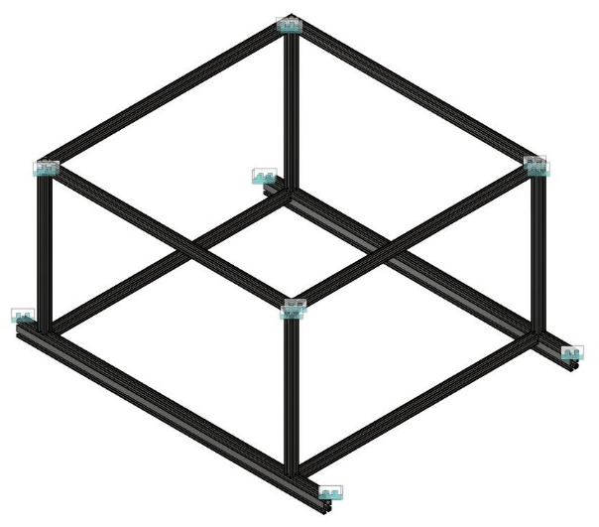
To build our robot, we will use aluminium profiles. These profiles are relatively lightweight but still sturdy, and using special connectors, they are easy to assemble. For the bottom-left and -right profile, we will use double profiles of 40x80 mm. The wheels will be connected to these profiles, so they have to be extra sturdy. All other parts of the frame will be singular profiles of 40x40 mm. The length of these double profiles is 1.54m instead of 1.20m because the wheels will be connected slightly on the outside of the main body of the robot. This makes the robot more stable in the dirt on the ground.

For driving, we will use 2 electric hub wheels at the front, and 2 swivel wheels at the back. The front wheels will move at the same speed when going in a straight line and at the moment of turning a corner, the wheels will move at different speeds. To connect the wheels to the frame, stainless steel brackets with a thickness of 6mm will be used. A 3D model of the bracket for the electric wheels can be found in the Appendix. The swivel wheels use a different shape, but we don’t know the exact dimensions of this bracket, as a teacher has designed and immediately ordered it for us.

Electronics
To ensure optimal functionality of our robot's control system while keeping the control software simple, we have decided to relieve the Raspberry Pi, which will handle the main control, by incorporating a second controller.
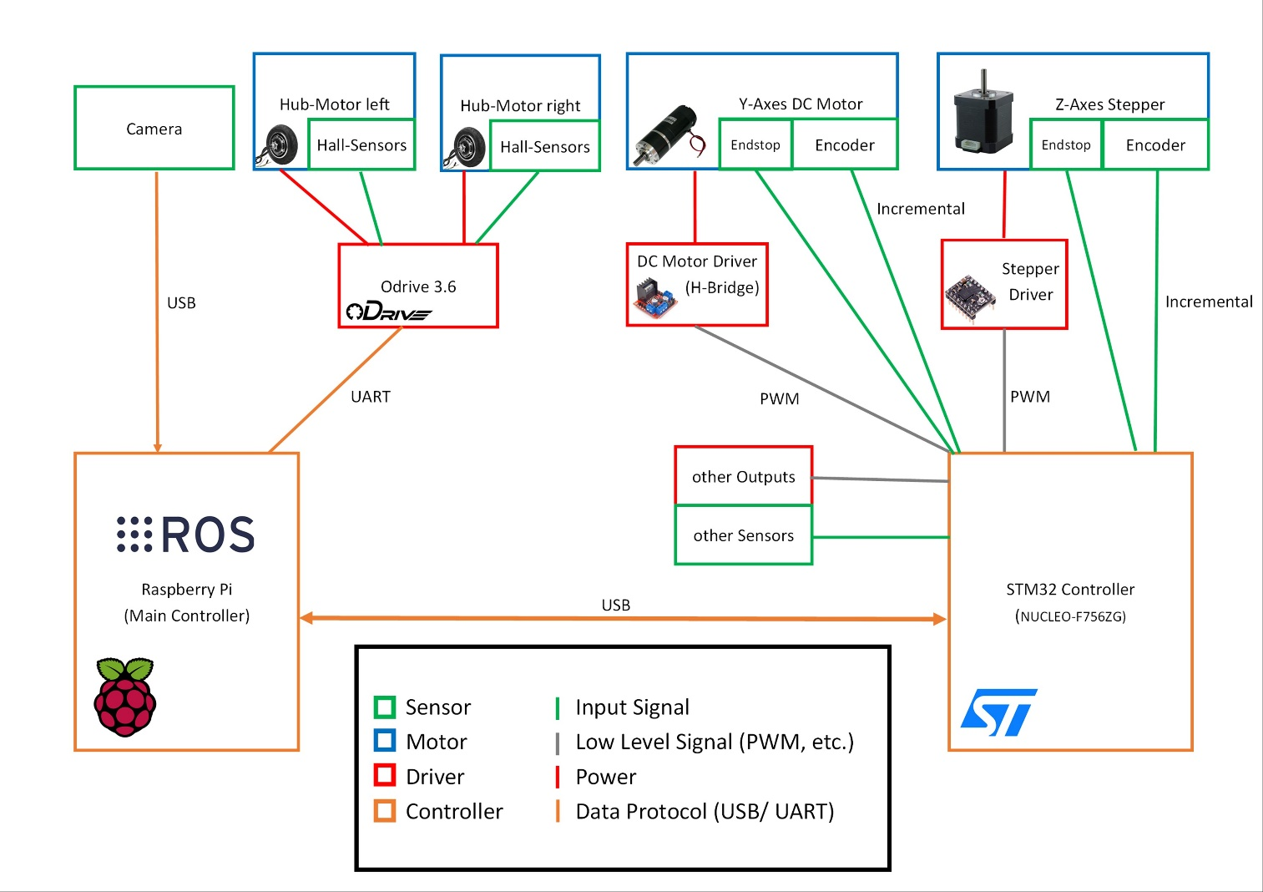
In the current electronics design (Figure 1: Electronics Overview), you can find a Raspberry Pi on the left side, responsible for handling more complex tasks and directly controlling the motor controller for the drive motors, as it already manages all motion control tasks. Furthermore, on the right side, you can identify the second controller, consisting of an STM32 Development board. This controller has a high clock rate, numerous input and output ports, and comes at a cost of approximately 30€.
Figure 1: Electronics Overview

Raspberry Pi
Our main controller is a Raspberry Pi, as it is a well-known small Linux computer that is sufficient for our requirements. As will be described later, our robot will run on the "ROS" software, which is also highly compatible with such a Raspberry Pi. The Raspberry Pi will process a camera feed and then plan/calculate the robot's movements; it will also control the gripper.
Therefore, it needs sufficient computing power to handle all these tasks. While it is possible to use a proper minicomputer instead of the Raspberry Pi, it would be more expensive and is currently not necessary. However, consideration has been given to the possibility that in the future, such a minicomputer could potentially replace the Raspberry Pi.
This is another reason to use the second controller for many smaller tasks and the motion control functions of the gripper. If the Raspberry Pi is to be replaced, there should be no problems connecting the existing robot electronics to the new PC, which most likely will not have its GPIO header like the Raspberry Pi. Thus, a relatively straightforward replacement should be possible.
So, the only connections of the Raspberry Pi consist of a USB connection to the camera, a USB/UART connection to the second controller, and a USB/UART connection to the motor controller for the drive motors. Whether a USB or UART connection is used is ultimately relatively inconsequential, as a simple converter can be utilized to switch between protocols.

ODrive
To control the two main motors of the robot, we have opted for an "ODrive 3.6." This Electronic Speed Controller (ESC) is also widely used and recognized for its ability to effectively control and drive two Brushless DC Motors (BLDC Motors). Additionally, it is highly flexible, easy to set up, and user-friendly. Since our two lift motors are BLDC motors, we can control both of them very effectively using an ODrive, requiring minimal software development for their control. Moreover, ROS provides a predefined library for integrating the ODrive.
For assistance in positioning and control at low speeds, each BLDC motor is equipped with three Hall effect sensors at appropriate positions. This allows the ODrive controller to drive the three motor coils precisely and efficiently, enabling very slow and powerful movements of these two motors simultaneously. In this case, we have chosen a clone of the original ODrive, as the original is no longer manufactured, and its successor, which can only control one motor, is considerably more expensive and therefore not as budget friendly.

STM32
As a second controller to relieve the Raspberry Pi, we opted for an STM32 development board (NUCLEO-F756ZG). This board is connected by us with the driver of the stepper motor of the Z-axis, the driver of the DC motor of the Y-axis, and any encoders or sensors. Compared to other affordable microcontrollers, such as those from the AVR family, this STM32 has a relatively high clock rate and possesses several event-driven timers. This makes it well-suited to evaluate the fast input signals from the encoders without delay and with high precision.

With this encoder signal, the STM32 will also handle any motion control tasks for both or potentially multiple motors in the future. Therefore, the Raspberry Pi only needs to provide the desired position to this STM32, and all control issues will be resolved by the STM32. The STM32 will also take care of driving other electronics, allowing the GPIO header of the Raspberry Pi to remain as free as possible for easy interchangeability.

Software
In our team, we have three people dedicated to writing the software for the Agrobot. We have been able to split ourselves up into three main tasks, each of us focussing on one task. These tasks, and how they have been approached, are described below.

Pathfinding
Our robot will be operating in a competitive environment, where the layout of the planter boxes and delivery bins have been predetermined. Because of this, we don’t need an especially complicated solution. We felt that a simple solution is necessary for this project, given the tight time constraint of a few months.
This time constraint also changed the way we approached the development of the software, we have decided to create a simulation so that we can write software while the hardware is being designed and assembled. For the simulation, we have chosen to use Webots, because this simulator seemed to have good documentation and is quite popular in the ROS2 community.

Considerations
There are many ways to solve the problem of pathfinding, some are very flexible but complicated to implement, such as SLAM. SLAM is the industry standard for pathfinding, but it is very expensive. It is also completely unnecessary because of the environment the robot will operate in.
A middle of the road solution would be a GPS system. This can be very accurate when paired with a base station. This is still quite difficult to implement, but a lot cheaper than a system like SLAM. The accuracy of the base station would allow us to know exactly where we are at, allowing us to base the navigation solely on the coordinates received from the GPS. This again seemed like an overly complicated solution for our problem, since the determination of the position can be solved more easily.

Solution
In our chosen solution we decided to make use of markers which would denote the start and end of the planter boxes and delivery bins, so the Agrobot knows when to stop or start delivering and collecting crops. These markers are placed on the ground and are recognized by the camera which is already used to determine the type of crop it is currently harvesting.
While the Agrobot is in between the markers, so either delivering or harvesting, it should do some course correction to make sure the Agrobot is not positioned in an unexpected angle. We have decided to use the borders of the planter boxes and delivery bins, since these should be at a right angle relative to the camera. If they are not, we can simply slow down one of the wheels until the lines of the box are straight again.

Gripper
The gripper in our projects needs to be able to effectively harvest a variety of different crops. In our case we are required to harvest 4 different crops: carrots, lettuce, beetroot and radish. A breakdown of the gripper workflow can be found below.

Considerations
The Agrobot is a complex multi-purpose robot that needs to be able to recognize and harvest a large variety of different crops. Each crop has a different structure which in result means that the gripping process must vary from plant to plant.
Another problem is that the gripper needs to know exactly where to grip the plant to harvest it in the most efficient way possible without inflicting any damage to the crop. The Agrobot will need computer vision and/or different sensors to be able to indicate the optimal position of the gripper that will result in a successful harvest of the crop.

Solution
The gripper will use a combination of different components on the robot to be able to harvest the crops successfully. Most of the work will be handled through ROS.

Computer Vision
The gripper will make use of the main camera that does the image recognition to identify the type of crop. Based on the type of crop the gripper will make use of 4 different scripts, each specific for one of the 4 types of crops that we need to harvest.
Once the image recognition camera has scanned the entire planter box the gripper will start a loop that will harvest each one of the crops inside the pixels in order until all the crops have been harvested and collected inside the bins.

Gripper Design
The crops are made from plastic which makes it a lot easier for us to develop the gripper design. This means that we no longer have to worry about damaging the plants and removes a decent chunk of complexity when it comes to the gripper.
The final design we landed on is a simple 2 finger design.

Camera vision and crop recognition

To harvest crops and place them in the correct harvesting box we need to identify the crop. This will be done with an object detection model we need to custom-train. To train the model we have to recreate the playing field environment and take example images and train the model.

Hardware
The image detection will be done on a laptop connected to a Raspberry PI with the camera. The raspberry PI will stream the video to the laptop where the image detection will happen.

Software
The model used in the object detection is YOLOv8. The labelling of the images is done with an online tool and training done on google colabs servers

Appendix

Wheel bracket
